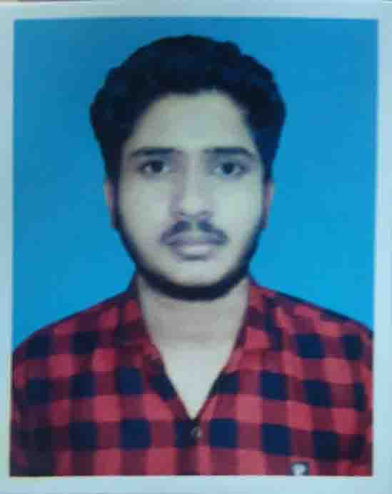Objective **Objective**

Seeking innovation and challenging career in a growing organization which gives me an opportunity to utilize my skills & knowledge and provides me an opportunity for career growth.

**OBJECTIVE:**



**Father’s Name :** Tajul Islam

**Mother’s Name :** Karima Begum

**Gender :** Male

**Marital Status :** Unmarried

**Nationality :** Bangladeshi

**Hobbies :** Reading Books

**Adress :** Palash, Narsingdi, Dhaka

**Declaration:** All the above information is correct up to my knowledge and I bear the responsibility of the correctness.

**SKILLS ENHANCEMENT TRAINING:**

**Training title:** Graphics Design

**Duration:** 1 Month

**Institution:** Pentanic IT

* Starting B.SC. Engg. in Computer science And Engineering From 2022
* **University:** Patuakhali science And Technology
* Intermediate Hsc from Narsingdi Govt. College in 2021
* Secondary from Goyespur P.L. High School in 2019

**Academic Profile:**

**Personal Information:**

* Playing Cricket
* General member of Bhadon
* Volunteer of CSE Club

**SKILLS**

**EXTRACURRICULAR ACTIVITIES**

**LANGUAGE**

* English
* Bangla
* Hindi
* Arabic
* Programming
* Adobe Photoshop
* MS Excel
* MS WORD
* AutoCAD
* Ms Power Point
* Scratch programming
* Ms Visio

Email:mdabulbasarbasar025@gmail.com

Patuakhali,Narsingdi

Mobile:01875576476

MD.ABUL BASAR